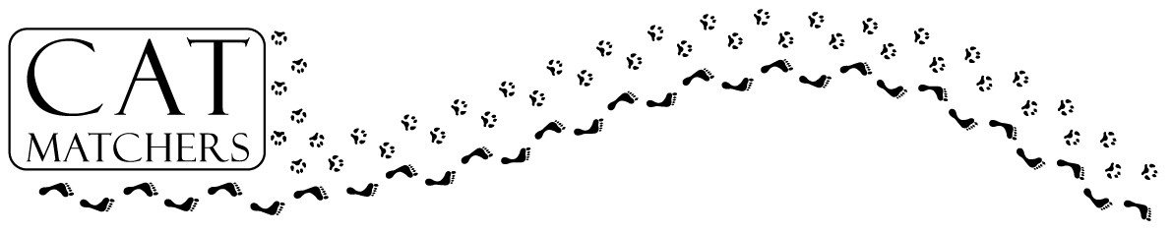



March 18, 2008

4-9pm

Feasting for Felines “Fun”- raiser

What a Deal - Help Homeless Cats and
Eat a Great Meal!

How it works: When you purchase a plate you help improve the feline fate! A percentage of all qualified food/beverages purchases will be donated back to Cat Matchers. To qualify, you simply present this flyer when you order/pay.

Where: Tin Star, NE corner of Alpha & Tollway, by the Galleria
13710 Dallas Parkway, Suite G, Dallas, TX 75240, 972-458-2000

Please take time to dine, for a "Purr-fect" cause
So, spread the word today! Get your family and friends together for dinner on March 18th at Tin Star to help Cat Matchers raise money.
Dallas Cat Rescue, dba Cat Matchers is an all-volunteer 501c3 organization dedicated to reducing the number of homeless animals. We will accomplish this through programs to rescue, spay/neuter and adopt out animals in need. All of the money raised goes to pay for these programs.

March 18, 2008

4-9pm

Feasting for Felines “Fun”- raiser

What a Deal - Help Homeless Cats and
Eat a Great Meal!

How it works: When you purchase a plate you help improve the feline fate! A percentage of all qualified food/beverages purchases will be donated back to Cat Matchers. To qualify, you simply present this flyer when you order/pay.

Where: Tin Star, NE corner of Alpha & Tollway, by the Galleria
13710 Dallas Parkway, Suite G, Dallas, TX 75240, 972-458-2000

Please take time to dine, for a "Purr-fect" cause
So, spread the word today! Get your family and friends together for dinner on March 18th at Tin Star to help Cat Matchers raise money.
Dallas Cat Rescue, dba Cat Matchers is an all-volunteer 501c3 organization dedicated to reducing the number of homeless animals. We will accomplish this through programs to rescue, spay/neuter and adopt out animals in need. All of the money raised goes to pay for these programs.

